Report for the lab 10

Firstly we created the table „calendar”:

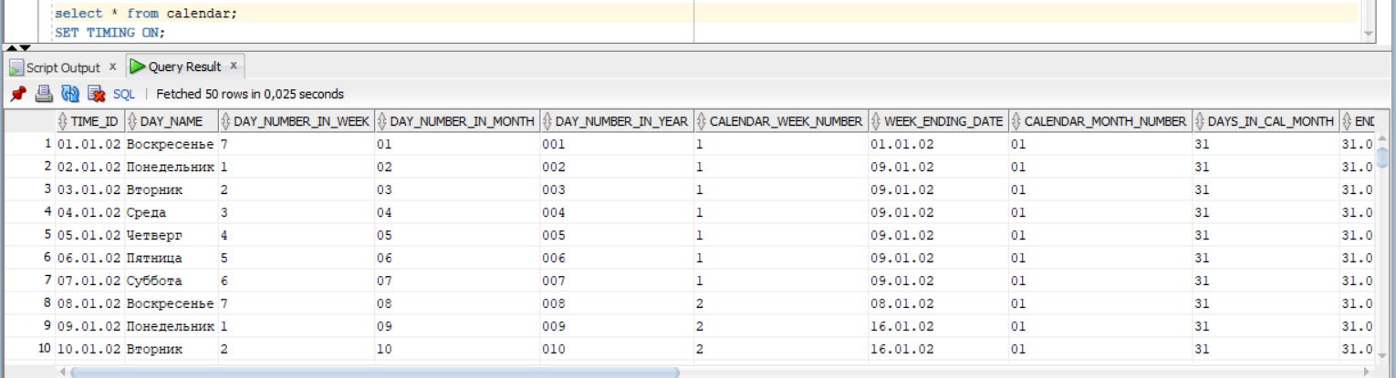

Thanks prompt „set time on” we can see how long the select is executed.

SELECT

Without parallel it lasts 8.6 seconds (5000 rows selected):

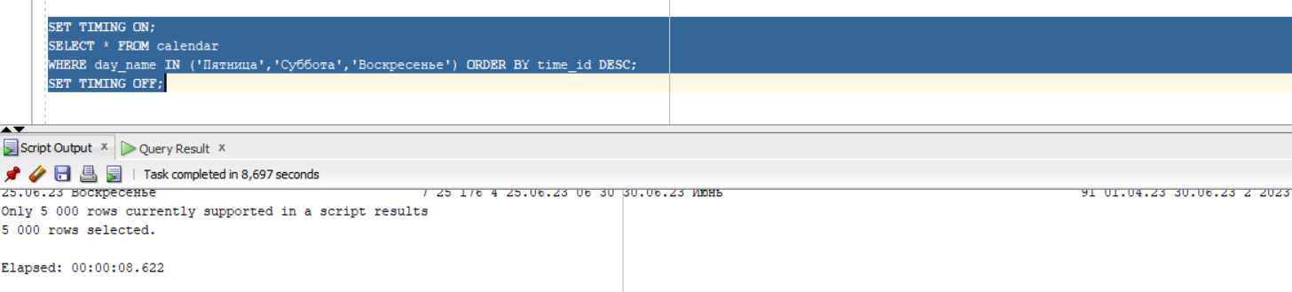

Explain plan:

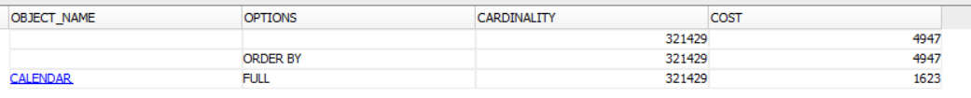

With- 7.2 seconds (degree ‘2’):

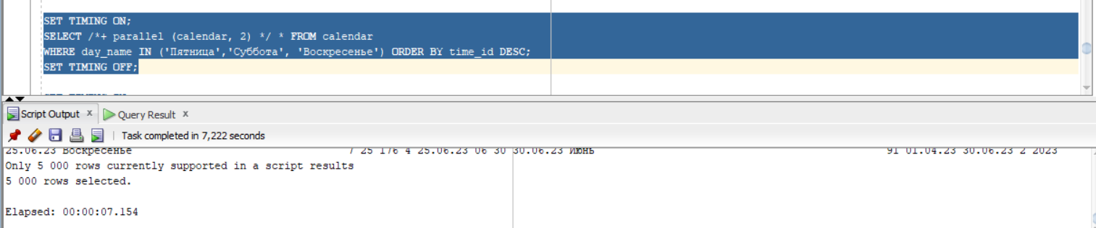

Explain plan:

As we can see the cost value is smaller than in the no-parallelism case.

Also the column about distribution is added, so we see the range access method is used:

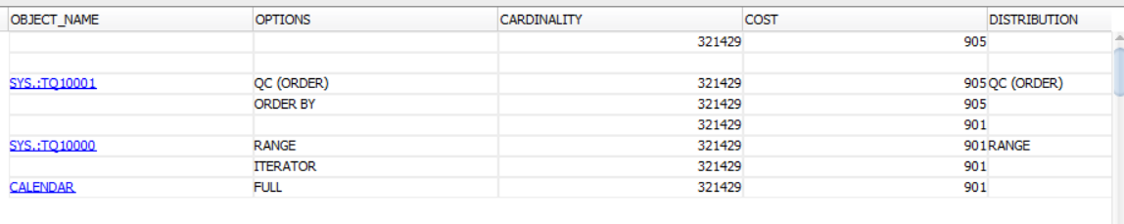

With degree ‘4’ 9 seconds:

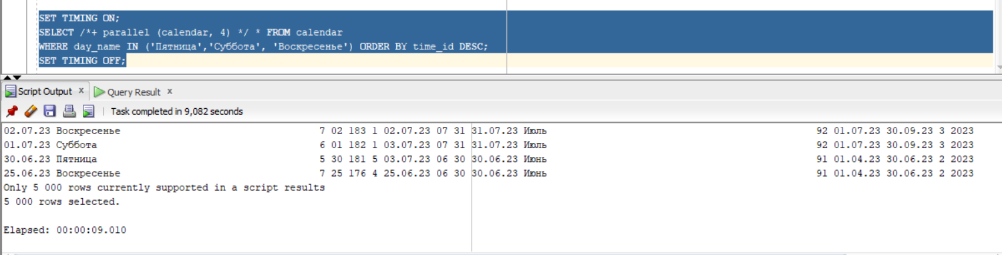

Explain plan:

The value cost is smaller than without parallelism, but the the execution time is bigger (the multithreading also takes time)

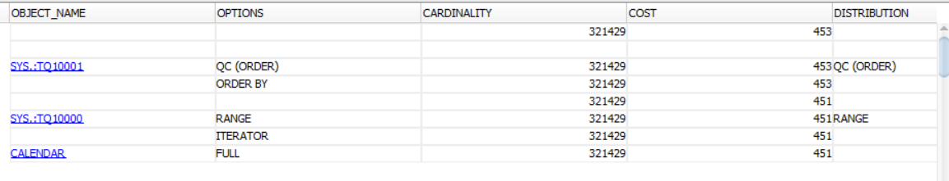

As we can see with the parallel degree equals 4 the process executes slower than with 2. It is because the number of rows is small.

DELETE

For this task part I dropped and created table every time, because oracle loads often executed commands into the cash, because of it the speed of the execution can be higher than the natural.

Without parallel:

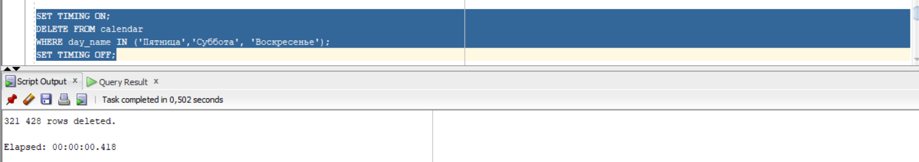

Explain plan

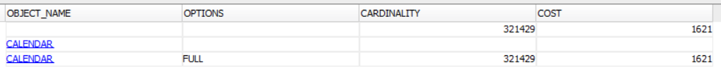

With parallel degree 2:

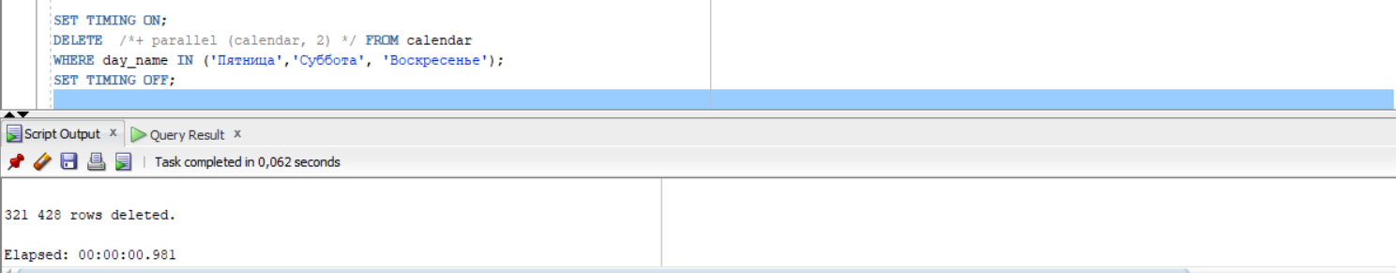

Explain plan:

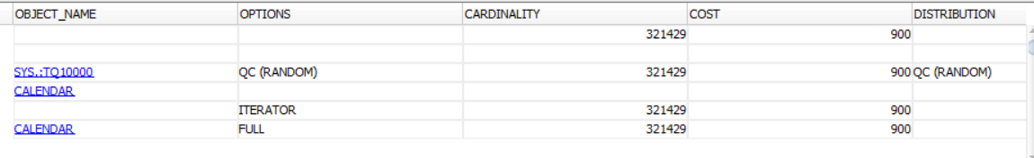

With parallel degree 4:

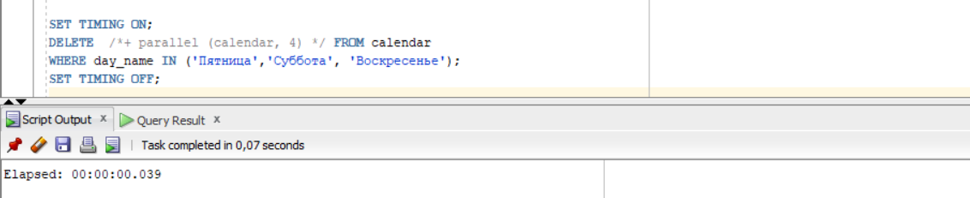

Explain plan:

The cost is smaller value cost than in the case with degree 2. And the time also is smaller:

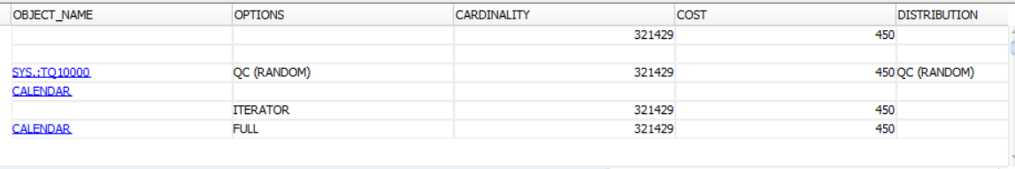

DROP

Without parallel execution:

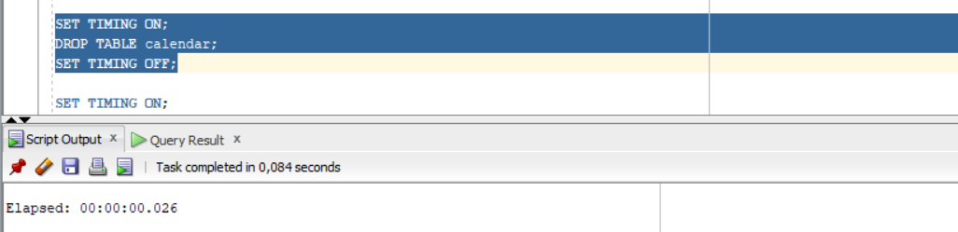

With 2 degree:

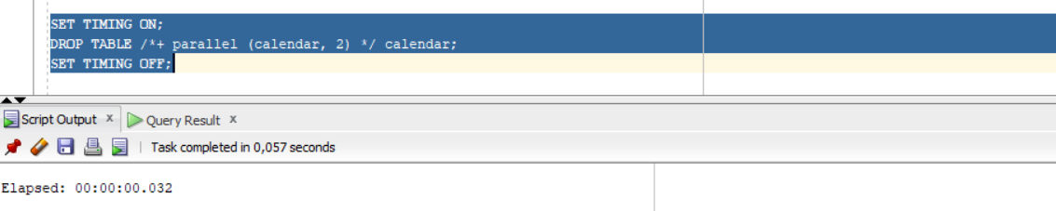

With 4 degree:

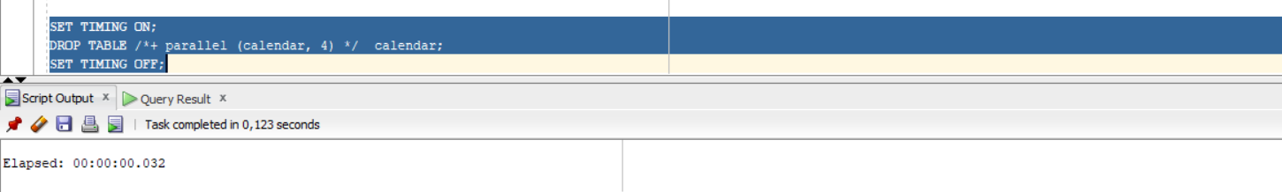

Due to all screenshots we can conclude that the most effective degree value is 2. In our case, multithreading only slows down the process due to resource consumption.